**IQRA University**

**Computer Science Department**

**Project Management**

**Extra Quiz**

**Submission Deadline: 21st May’ 2020 – 9:00 P.M.**

At ABC Software, you are convincing your boss that he should consider modern project management techniques to manage a complex project. Your boss says that he doesn’t need anything fancy, and that he can guess the total time by the seat of his pants. To prove your point, you decide to use a very simple example of a commercial software project, with six tasks.

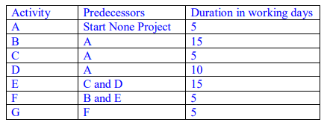

1. **Create a network diagram.**
2. **Find out the critical path using critical path method (slack method).**
3. **Find out the variance for all the critical activities.**
4. **What is the probability that the project will end in:** 
   1. **The project will end in 45 days**